**SpendWise Website**

Submitted in partial fulfillment of the requirements of the degree of

BACHELOR OF COMPUTER ENGINEERING

by

Pawar Sahil Sanjay 23102156 Panchal Ujwal Dasharath 23102020 Oswal Sahil Manoj 23102057

Guide:

Prof. Priyanka M. Lohot



Department of Computer Engineering

A. P. SHAH INSTITUTE OF TECHNOLOGY, THANE

(2024-2025)



A. P. SHAH INSTITUTE OF TECHNOLOGY, THANE

**CERTIFICATE**

This is to certify that the Mini Project 1B entitled “**SpendWise Website**” is a bonafide work of **Sahil Pawar (23102156), Ujwal Panchal (23102020), Sahil Oswal (23102057)** submitted to the University of Mumbai in partial fulfillment of the requirement for the award of the degree of **Bachelor of Engineering** in **Computer Engineering.**

Guide Project Coordinator Head of Department

Prof. Priyanka Lohot Prof. Deepali Kayande Dr. S. H. Malave

 s A. P. SHAH INSTITUTE OF TECHNOLOGY, THANE

Project Report Approval for Mini Project- 1B

This project report entitled “**SpendWise*”*** by ***Sahil Pawar, Ujwal Panchal, Sahil Oswal,*** is approved for the partial fulfillment of the degree of ***Bachelor of Engineering*** in ***Computer Engineering***, ***2024-25.***

Examiner Name Signature



Date:

Place:

# Declaration

We declare that this written submission represents my ideas in my own words and where others' ideas or words have been included, I have adequately cited and referenced the sources. I also declare that I have adhered to all principles of academic honesty and integrity and have not misrepresented or fabricated or falsified any idea/data/fact/source in my submission. I understand that any violation of the above will be cause for disciplinary action by the Institute and can also evoke penal action from the sources which have thus not been properly cited or from whom proper permission has not been taken when needed.

Sahil Sanjay Pawar – 23102156

Ujwal Dashrath Panchal – 23102020

Sahil Manoj Oswal – 23102057

Date:

# Abstract

This project is based on an expense and tracking system. This project aims to create an easier, faster, and smooth tracking system between the money spend and the money earned. We are making an website which is named “SPENDWISE WEBWEBSITE”. This is the website that is used to track the daily expense of a student. So, for a better expense tracking system, we developed a project that will help the users a lot. Most the student because of their busy schedule find it difficult to calculate their expense and income which is the one reason they face money crisis, in this case, a daily expense tracker can help the student to track income-expense day today and make life tension free and focus easily on their career. It is like a digital diary that keeps a record of expenses done by a student. The website keeps track of money spent and the earnings of both of the students on a day-to-day basis. This website helps the user to easily calculate his/her expenses on daily basis and he/she has not to write down every transaction on paper and do the hectic calculation, it simply makes the task easier.

**Background**

Managing personal finances is a challenge, especially for students with limited budgets. The Student Expense Tracker Website is designed to help students monitor and manage their daily expenses efficiently, promoting financial awareness and discipline.

**Aim**

The aim of the project is to provide students with a user-friendly tool to categorize and track their expenditures, ensuring they stay within their budget limits.

**Method used**

The website is developed using a mobile-friendly interface with features such as income and expense logging, categorization of expenditures (e.g., food, transport, entertainment), and a summary dashboard displaying the financial status.

**Results**

The website successfully allowed students to better visualize their spending patterns and adjust their budgeting behavior accordingly. Users reported an increase in financial awareness and improved money management. The Student Expense Tracker website serves as a practical solution for students aiming to improve their financial literacy and maintain control over their expenses.

**Keywords**: Expense Tracker, Student Finance, Budget Management, Financial Awareness, Daily Expense Logging, Income Tracking, Money Management, Personal Finance, Digital Diary, Web-based Application, SPENDWISE, Expense Categorization, Financial Literacy, Expense Monitoring, Budget Planning.

# CONTENTS

|  |  |  |
| --- | --- | --- |
| **Sr. No.** | **Chapter Name** | **Page No.** |
| **1** | **Introduction** | **8** |
| **2** | **Literature Survey** | **10** |
| **3** | **Problem Statement, Objective & Scope** | **12** |
| **4** | **Proposed System** | **14** |
| **5** | **Project Plan** | **23** |
| **6** | **Experimental Setup** | **25** |
| **7** | **Implementation Details** | **26** |
| **8** | **Results** | **27** |
| **9** | **Conclusion** | **31** |
| **10** | **References** | **32** |
| **11** | **MOOC Certificate** | **33** |

**LIST OF FIGURES**

|  |  |  |
| --- | --- | --- |
| **Sr. No.** | **Figure Name** | **Page No.** |
| **1** | **Architecture Diagram** | **15** |
| **2** | **Flow Chart** | **16** |
| **3** | **Extended Entity Relationship Diagram** | **17** |
| **4** | **Relational Schema Diagram** | **18** |
| **5** | **Gantt Chart** | **19** |



**LIST OF TABLES**



|  |  |  |
| --- | --- | --- |
| **Sr. No.** | **Table Name** | **Page No.** |
| **1** | **Schema Design** | **20** |
| **2** | **Data Dictionary** | **21** |



# Chapter 1 Introduction

**1.1 Overview**

In today's fast-paced world, financial management has become increasingly important, especially for students who often operate on limited budgets. SpendWise is a comprehensive expense tracking website designed specifically to address the financial management needs of students. The platform functions as a digital diary for financial transactions, helping students monitor their spending habits, track income sources, and maintain budget discipline.

**1.2 Background**

Managing personal finances is a critical life skill, particularly for students who are often dealing with limited income streams and the pressures of budgeting. With the advent of digital finance management tools, students can now gain a better understanding of their spending habits and take charge of their financial futures. The Student Expense Tracker Website project focuses on solving this financial literacy challenge by providing students with a simple, user-friendly solution to manage their expenses.

Most students face financial management challenges due to:

* Lack of time to manually track expenses
* Limited knowledge of budgeting practices
* Difficulty in categorizing and analyzing spending patterns
* Inconsistent income sources (part-time jobs, allowances, scholarships)
* Unexpected expenses that disrupt budget planning

**1.3 Project Purpose**

SpendWise aims to create an easier, faster, and smoother tracking system between money spent and money earned. It serves as a digital financial assistant that helps students:

* Track daily expenses across various categories
* Monitor income from different sources
* Analyze spending patterns through visualizations

**1.4 Why Choose SpendWise**

SpendWise is designed with students in mind, making budgeting simple, intuitive, and effective. With rising expenses and the need for better financial management, SpendWise empowers users to track every penny, helping them make informed decisions about their spending habits. Whether it's pocket money or part-time income, SpendWise keeps users in control, ensuring they save where it matters most.

**1.5 Key Features**

1. **Comprehensive Expense Tracking**: Categorize and monitor spending in areas like food, travel, shopping, education, and more.
2. **Secure Login & Registration**: Simple, secure authentication to keep financial data safe.
3. **Mobile & Web Integration**: Manage finances on the go with our mobile-friendly website design.
4. **Savings Calculation**: Automatically track savings when spending is less than the allocated budget.
5. **Category-wise Analysis**: Understand spending patterns across different expense categories.

**1.6 Our Commitment**

At SpendWise, we are committed to helping students build responsible financial habits that last a lifetime. We aim to create an accessible platform that's easy to use, ensuring that students are equipped to manage their finances efficiently. Our dedication to security, privacy, and user-friendly design ensures that SpendWise remains a trusted companion in the financial journey of students.

# Chapter 2

# Literature Survey

**2.1 Introduction to Personal Finance Management**

Importance of Financial Literacy: Research has shown that many students face challenges in managing their personal finances due to a lack of financial literacy. Studies like those by Lusardi & Mitchell (2014) highlight the gap in financial knowledge, especially among young adults. Financial Behavior of Students: Research by Sabri & MacDonald (2010) examines how students’ financial behavior is influenced by various factors, such as parental guidance, educational background, and peer influence.

**2.2 Expense Tracking websites Existing Solutions**

Explore popular expense tracking websites such as Mint, YNAB (You Need A Budget), Pocket Guard, etc. These websites provide key features like budgeting, tracking expenditures, and generating reports. Analyzing their success, usability, and effectiveness can guide the design of ‘SpendWise.’

Gaps in Existing Systems: Many existing websites are general-purpose, meaning they aren’t specifically designed for students. This can make them overwhelming, as students typically require simple, specific solutions for tracking daily or weekly expenses, understanding where their money is going, and budgeting for rent, groceries, and education costs.

**2.2 Financial Behavior of Students**

Research by Sabri & MacDonald (2010) examines how students' financial behavior is influenced by various factors, such as parental guidance, educational background, and peer influence. Their study found that students who received financial education were more likely to engage in positive financial behaviors, such as maintaining a budget and saving regularly.

Additional research has shown that financial stress can negatively impact academic performance, with students worrying about finances reporting higher levels of anxiety and decreased concentration on studies. This highlights the importance of effective expense tracking and budget management tools specifically designed for the student demographic.

| Research Paper | ANALYSIS |
| --- | --- |
| 1. Sharma, R., & Patel, A. (2021). “Student Expense Tracker: A Web-Based System for Personal Finance Management.” International Journal of Computer Applications. | This paper discusses the development of a web-based expense tracking system aimed at helping users, especially students and young professionals, manage daily expenses and gain financial awareness through smart budgeting features |
| 2. OECD (2016). *International Survey of Adult Financial Literacy Competencies*. | Explains how digital applications can positively influence financial habits when targeted correctly to the audience—students in this case. |
| 3. Dwivedi, Y. K., et al. (2017). "Research on information systems and social media: A focus on apps for personal finance." *Journal of Business Research*. | This paper discusses the adoption of digital tools and apps in personal finance and supports the use of mobile/web platforms like SpendWise. |
| 4. Goyal, S. (2018). Advertising on social media. Scientific Journal of Pure and Applied Sciences | This paper explains the use of social media in the recruitment process. The applications like LinkedIn are widely used. |
| 5. Agarwal, S., & Mazumder, B. (2013). "Cognitive abilities and financial behavior." *American Economic Journal: Applied Economics*. | Demonstrates how cognitive ability impacts financial decisions, reinforcing the need for intuitive, student-friendly tools like SpendWise. |

# 

# Chapter 3

# Problem Statement, Objective & Scope

**3.1 Problem Statement**

To design and implement a comprehensive expense tracking website specifically tailored for students, enabling them to efficiently monitor their daily expenses, manage budgets, and build financial literacy using modern web technologies.

Students often struggle with financial management due to their busy academic schedules, leading to poor tracking of expenses and income. This situation frequently results in financial stress, unplanned spending, and difficulty in saving money. Most existing financial tools are either too complex or not specifically designed for the unique financial situations students face, such as irregular income from part-time jobs, semester-based expenses, and limited budgets.

The SpendWise Website aims to solve these problems by providing a user-friendly digital platform that functions as a personal financial assistant. The system will allow students to log and categorize expenses, track income sources, set budget limits, receive notifications about potential overspending, and visualize spending patterns to make informed financial decisions. By automating the expense tracking process and providing insights into spending habits, SpendWise will help students develop better financial discipline and reduce the stress associated with money management.

* 1. **Objectives**

1. **Promote Financial Responsibility**: Help students develop better financial habits by tracking their income, spending, and savings patterns.
2. **Simplify Expense Tracking**: Provide an easy-to-use platform where students can log and categorize their daily, weekly, or monthly expenses efficiently without the hassle of manual calculations.
3. **Budget Creation and Management**: Enable students to create customized budgets based on their specific financial situations, set spending limits for different categories, and receive alerts when they approach or exceed those limits.
4. **Encourage Savings**: Motivate students to allocate a portion of their budget for savings by tracking unspent budget amounts and automatically adding them to a savings balance.
5. **Increase Awareness of Spending Patterns**: Help students identify areas where they may be overspending through visual representations of expense data and provide insights for potential cost-cutting opportunities.
6. **Develop Financial Literacy**: Incorporate educational components that help students understand basic financial concepts and develop skills for long-term financial well-being.

**3.3 Scope**

1. **User Authentication System**: Implement secure registration and login functionality to protect user financial data.
2. **Expense Tracking Module**: Allow students to log, categorize, and view their daily, weekly, or monthly expenses, helping them monitor their spending habits.
3. **Income Recording System**: Provide functionality to record various income sources such as allowances, part-time jobs, scholarships, or other financial support.
4. **Expense Categorization**: Implement predefined expense categories relevant to student life (e.g., food, transportation, education, entertainment) while allowing for custom category creation.
5. **Database System**: Design and implement a database structure to efficiently store and manage user profiles, transactions, budgets, and other relevant data.
6. **Responsive Web Design**: Ensure the website functions properly across desktop and mobile devices with an adaptive interface.

# Chapter 4

**Proposed System Architecture**

**4.1 Description of Proposed System**

The SpendWise Website is designed to be a comprehensive financial management system tailored specifically for students. The system follows a client-server architecture with a focus on responsiveness, security, and user experience.

The core functionality revolves around four main modules:

1. **User Management Module**: Handles user registration, authentication, profile management, and security aspects.
2. **Expense Management Module**: Manages the recording, categorization, and analysis of user expenses.
3. **Budget Control Module**: Enables budget creation, monitoring, and notification systems for budget adherence.
4. **Analytics and Reporting Module**: Provides visual representations of financial data and generates periodic reports.

The system will be implemented as a responsive web application using modern web technologies, ensuring accessibility across various devices. Data persistence will be handled through a relational database system, with proper security measures to protect sensitive financial information.

**ARCHITECTURE / BLOCK DIAGRAM**

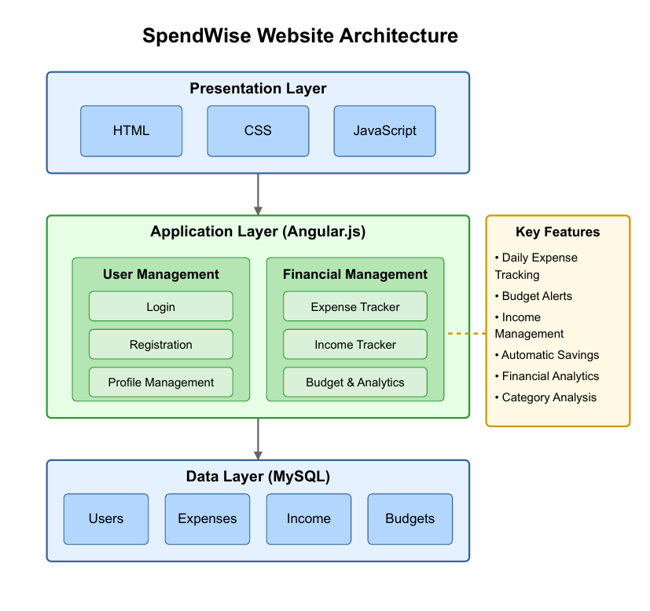

**FLOWCHART**

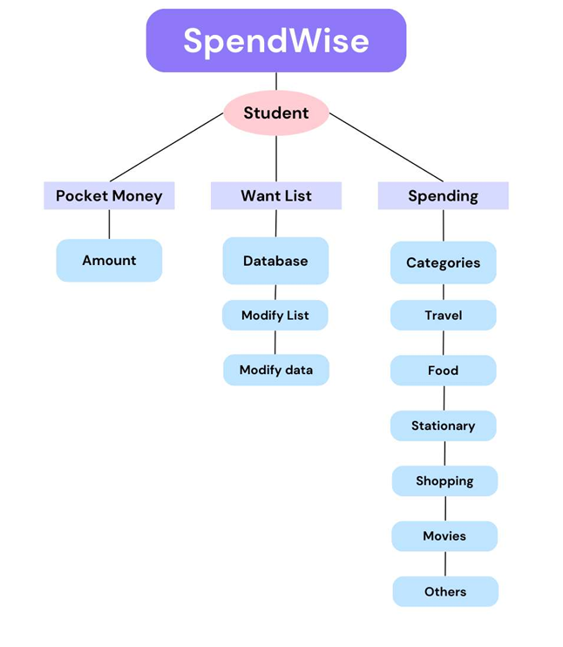

**ERR DIAGRAM**

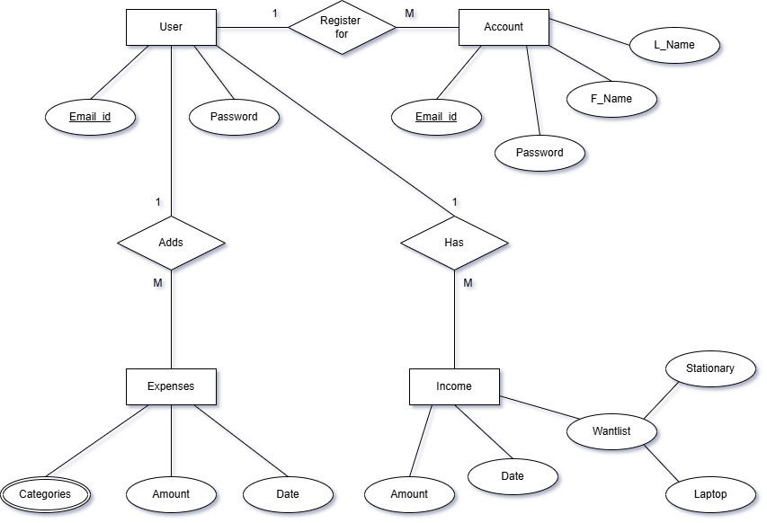

**RELATIONAL SCHEMA**

User:



Account:



Income:



Expenses:



**GANTT CHART**

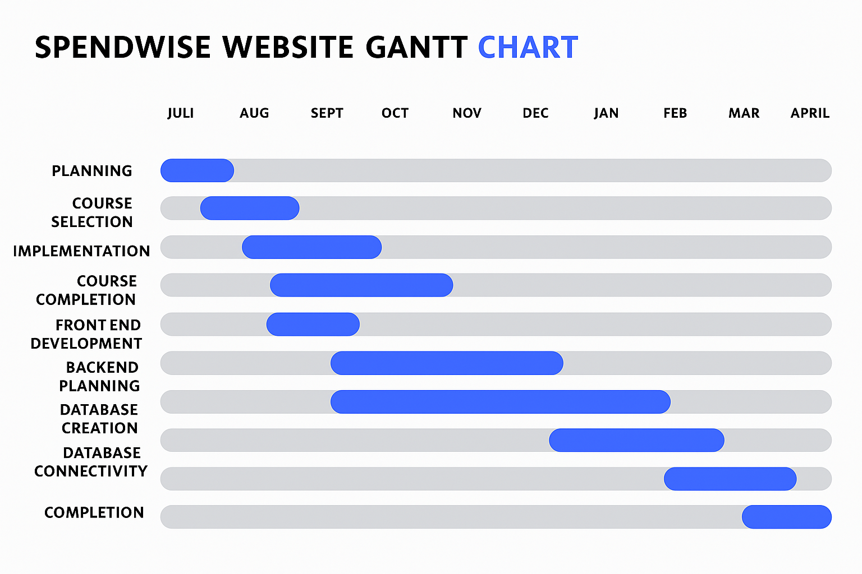

**SCHEMA DESIGN**

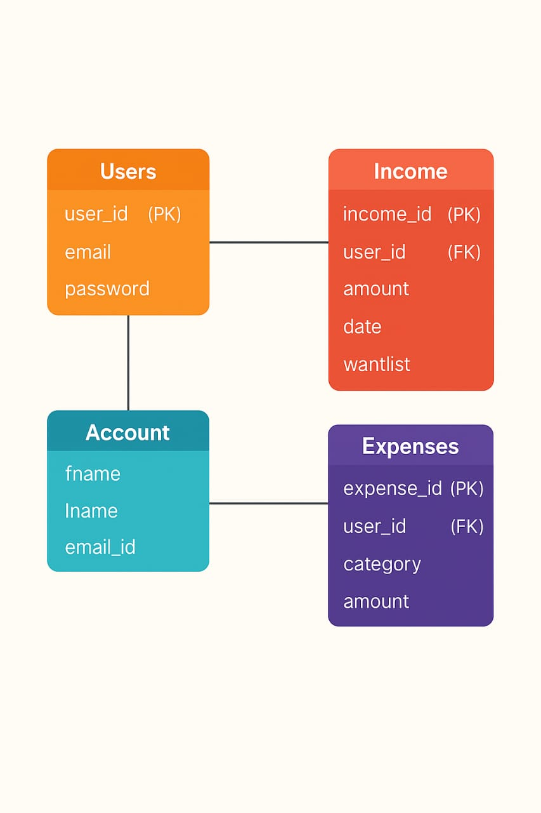

**DICTIONARY**

**4.1 User Table:**

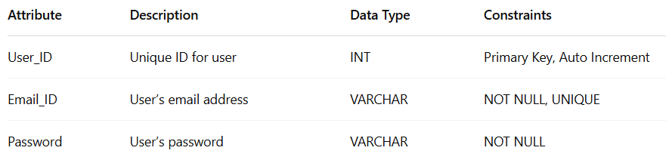

**4.2 Account Table:**

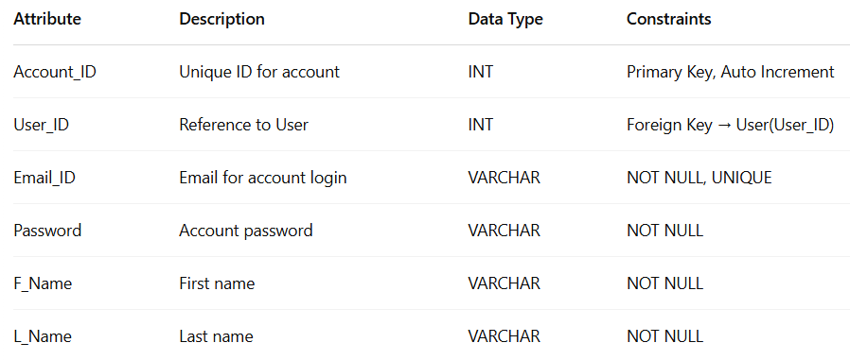

**4.3 Expenses Table:**

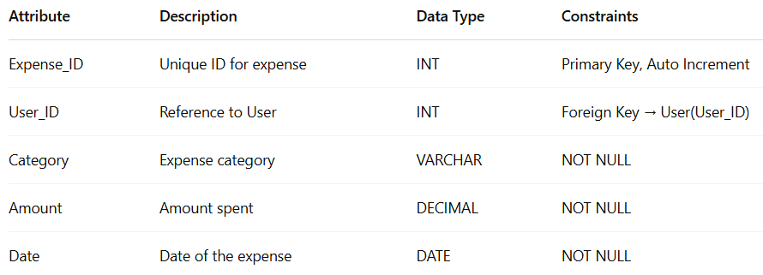

**4.4 Income Table:**

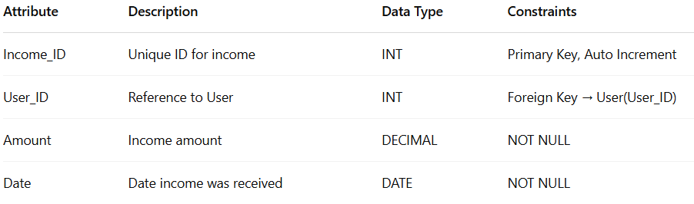

# Chapter 5

# Project Planning



The development of SpendWise follows a structured timeline with specific milestones and deliverables:

**Phase 1: Planning (July)**

• Defined project goals and feature set.

• Selected appropriate technology stack.

• Assigned team roles and responsibilities.

**Phase 2: Course Selection (August – September)**

• All three team members opted for and enrolled in the MOOC: “Android App Development Bootcamp with Java” by Abhishek Barkade on Udemy.

• Focused on gaining relevant skills for frontend, backend,

**Phase 3: Initial Implementation (September – October)**

• Designed UI components and wireframes.

• Drafted system architecture and initial layout structure.

• Created early versions of individual modules.

**Phase 4: Course Completion (September – October)**

• All group members successfully completed the course, gaining hands-on experience with Android Studio, Java, and MySQL.

• Acquired skills were directly applied to the SpendWise website.

**Phase 5: Frontend Development (October – November)**

• Implemented the web interface using HTML, CSS, and JavaScript.

• Ensured responsive design for mobile and desktop.

**Phase 6: Backend Planning (November – January)**

• Outlined database models and server-side architecture.

• Planned API endpoints and user authentication.

**Phase 7: Database Creation (January – February)**

• Developed the MySQL database with structured tables.

• Designed relationships between data entities.

**Phase 8: Database Connectivity (February – March)**

• Integrated the database with the backend using PHP.

• Established secure data flow between frontend and backend.

**Phase 9: Final Completion (March – April)**

• Performed testing and debugging.

• Finalized documentation (user guide, project report).

• Deployed the website and validated its performance.

# Chapter 6

# Experimental Setup

**6.1 Software Requirements:**

|  |  |
| --- | --- |
| **Technology** | **Purpose** |
| HTML | Frontend structure |
| CSS | Frontend styling |
| JavaScript | Frontend interactivity |
| Angular.js | Backend runtime |
| MySQL | Database management |
| Visual Studio Code | Development IDE |

**6.2 Hardware Requirements**

1. **CPU**: Intel Core i5 or equivalent (Minimum)
2. **RAM**: 8GB (Minimum)
3. **STORAGE**: 128GB SSD (Minimum)
4. **DISPLAY**: 1920x1080 resolution
5. **OS**: Windows 10/11, macOS, or Linux
6. **Network**: Broadband Internet connection

# Chapter 7

# Implementation Details

**7.1 Frontend Implementation**

The frontend of SpendWise is built using a combination of HTML, CSS, and JavaScript. The user interface is designed to be intuitive, responsive, and visually appealing, with a focus on accessibility and ease of use.

**7.1.1 User Interface Components**

1. **Authentication Module**: Implements the registration and login functionality with form validation to ensure data integrity.
2. **Dashboard**: Serves as the central hub for users, displaying summary information about expenses, income, budget status, and recent transactions.
3. **Expense Tracking Interface**: Provides forms and interfaces for users to log, categorize, and review their expenses with filtering and sorting capabilities.
4. **Budget Management**: Allows users to set and manage budget limits for different expense categories and tracks budget utilization.

**7.2 Backend Implementation**

The backend system is developed using Node.js with the Express framework, providing a robust and scalable architecture for handling user requests and data processing.

**7.3 Database Implementation**

The database for SpendWise is implemented using MySQL, with a normalized schema design to ensure data integrity and efficient querying. The database structure follows the entity-relationship model defined in Chapter 4, with appropriate indexes for performance optimization.

**7.4 Responsive Design Implementation**

To ensure accessibility across various devices, the frontend implements responsive design principles:

1. Fluid grid layouts that adapt to different screen sizes
2. Flexible images and media elements
3. Touch-friendly interface elements for mobile users

# Chapter 8

# Result

# 8.1 Landing Page:

# 

# 8.2 Login Page:

# 

8.3 Registration Page:

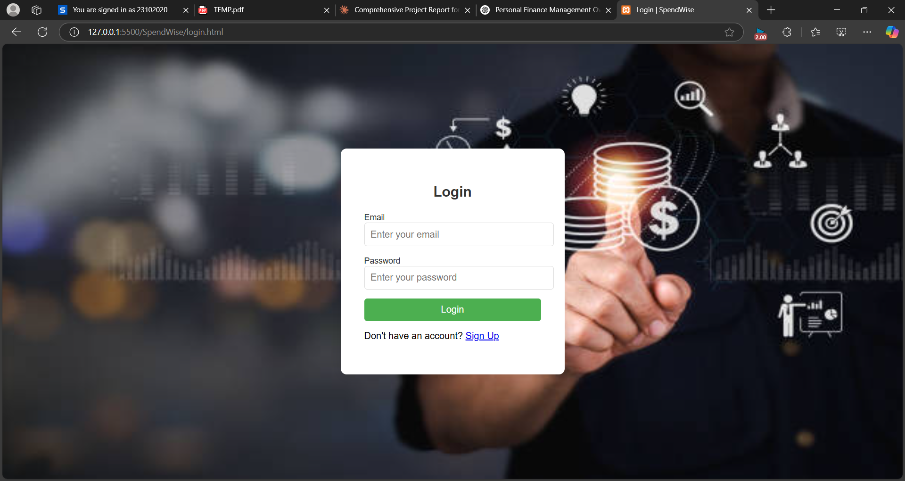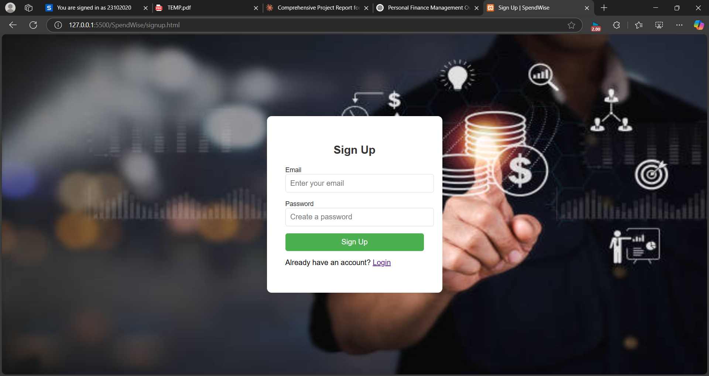

# 8.4 Income Page:

# 

# 8.5 Expenses Page:

# 

# 

# Chapter 9

# Conclusion

**9.1 Summary**

The SpendWise Website project has successfully delivered a comprehensive expense tracking and budget management solution tailored specifically for students. By focusing on the unique financial challenges faced by the student population, SpendWise bridges the gap between complex financial applications and the practical needs of young adults managing limited budgets.

The implemented system fulfills all the primary objectives outlined in the project scope, providing a user-friendly interface for expense tracking, budget management, and financial analysis. The responsive design ensures accessibility across various devices, allowing students to manage their finances anywhere, anytime.

**9.2 Achievements**

1. **Enhanced Financial Awareness**: SpendWise provides students with a clear picture of their spending patterns, promoting better financial decision-making.
2. **Simplified Expense Management**: The intuitive interface and automated calculations eliminate the need for manual tracking, saving time and reducing errors.
3. **Secure Financial Management**: The implementation of robust security measures ensures that sensitive financial data remains protected.
4. **Cross-Platform Accessibility**: The responsive design allows users to access their financial information across different devices, providing flexibility and convenience.

**9.3 Future Enhancements**

While the current version of SpendWise meets its core objectives, several potential enhancements could further improve the system:

1. **Financial Goal Setting**: Adding functionality for users to set specific financial goals (e.g., saving for a laptop, vacation) and track progress.
2. **Bill Reminder System**: Incorporating reminders for recurring bills and payments to help users avoid late fees.
3. **Social Features**: Implementing optional anonymized comparison with peers for budget benchmarking and financial habit formation.
4. **Mobile Application**: Developing dedicated mobile applications for iOS and Android to enhance the mobile user experience beyond responsive web design.

# Chapter 10

# References

* 1. Lusardi, A., & Mitchell, O. S. (2014). "The Economic Importance of Financial Literacy: Theory and Evidence." Journal of Economic Literature, 52(1), 5-44.
  2. Sabri, M. F., & MacDonald, M. (2010). "Savings Behavior and Financial Problems among College Students: The Role of Financial Literacy in Malaysia." Cross-Cultural Communication, 6(3), 103-110.
  3. McDonald, P., & Thompson, P. (2019). "Social media and the reshaping of public/private boundaries in employment relations." International Journal of Management Reviews, 18(1), 69-84.
  4. Goyal, S. (2018). "Advertising on social media." Scientific Journal of Pure and Applied Sciences, 7(1), 379-386.

# Chapter 11

# MOOC Certification

During the development of the *SpendWise* project, all three group members Sahil Pawar, Ujwal Panchal and Sahil Oswal successfully completed the MOOC "Android App Development Bootcamp with Java" on Udemy, instructed by Abhishek Barkade. The 9-hour course provided a solid foundation in Android development using Java, which contributed significantly to the technical aspects of the project. A sample certificate is attached below as proof of completion.

